UML Diagrams

UML Use case Diagram
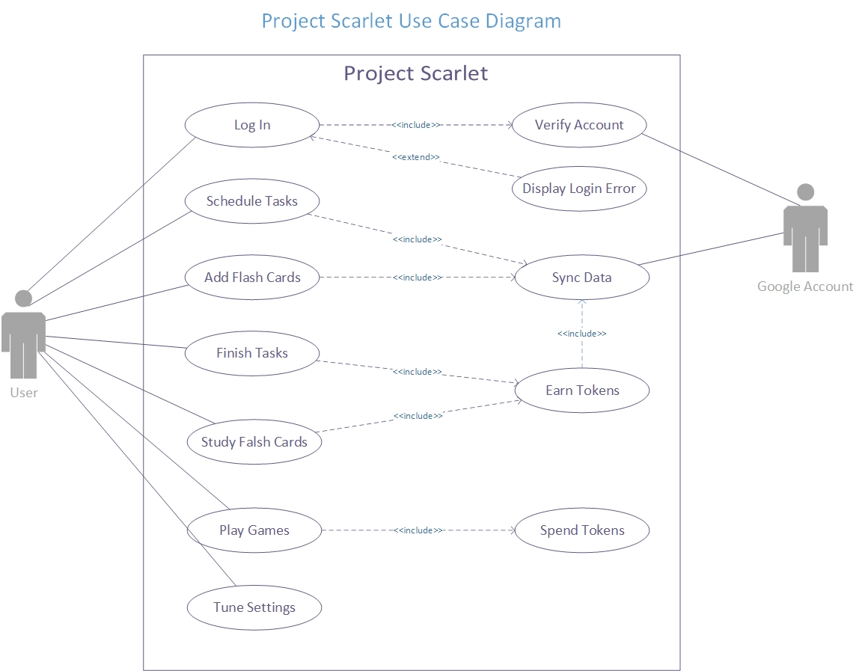

UML Sequence Diagram

Account Sub-part

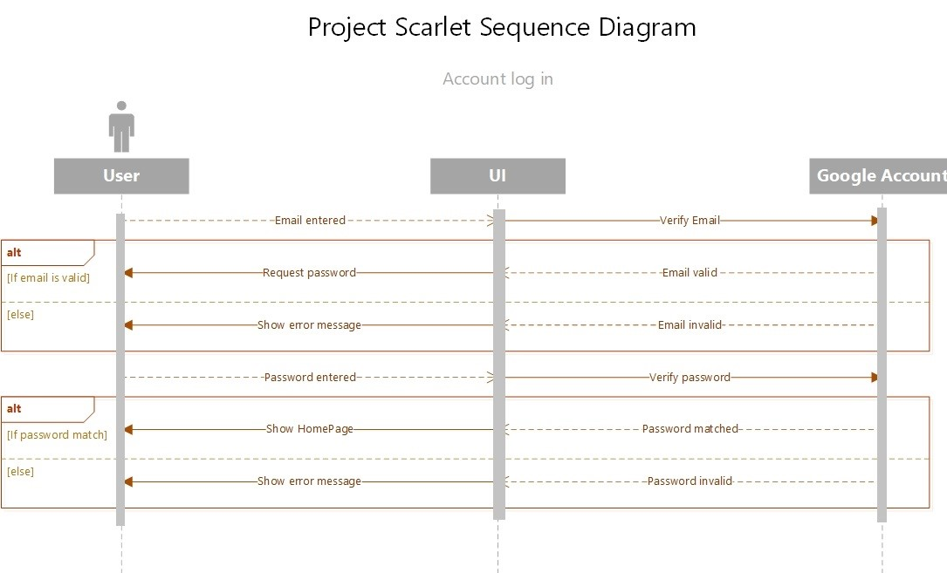

Strategic Sub-part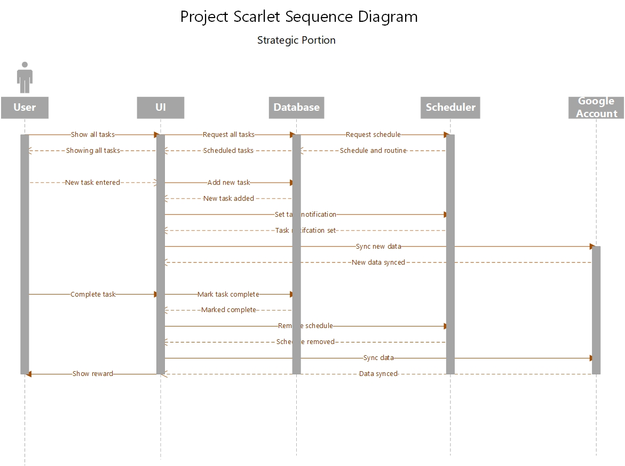

Wisdom Sub-Part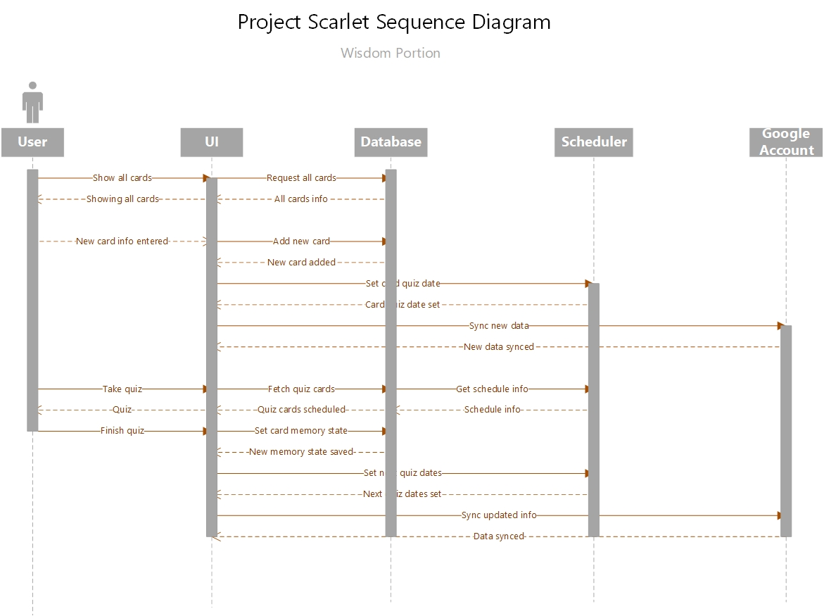

UML Class Diagrams

Strategy Sub-part
The strategy sub-part of the application can be viewed and interacted with, using the StrategyPage class. This class depends on BasicPage class for the basic layout of the page. The class shows two tabs which show the upcoming and overdue tasks. These are maintained by the UpcomingTasks and OverdueTasks classes respectively. Both these classes are dependent on the TaskDatabase class to get the tasks scheduled. The task notification is handled by TaskNotification class. This class schedules and reschedules notifications of tasks.
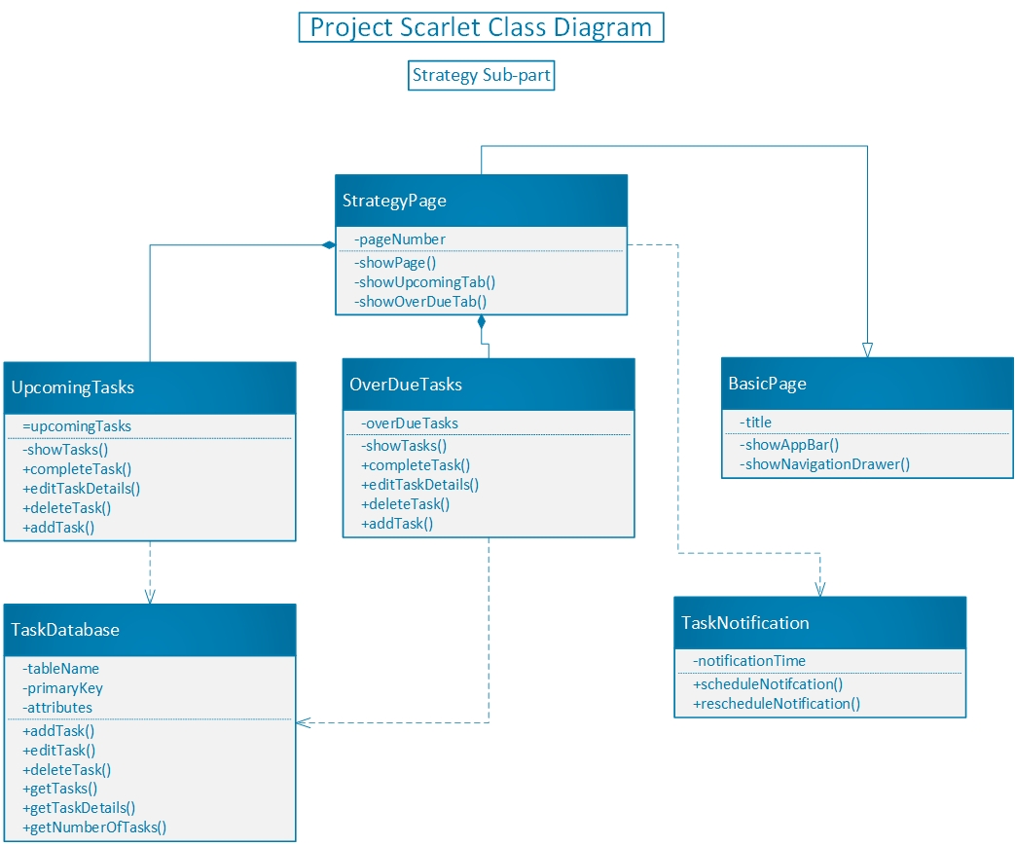

Wisdom Sub-part
The wisdom sub-part of the application can be viewed from the WisdomPage class, which depends on the BasicPage class for basic layout of the page. The WisdomPage class shows a list of topics the user has created. Upon clicking on a topic, the user will be directed to a page containing the decks of that topic. A topic might have zero or more decks. This page’s functionality is maintained by the DeckPage class. Now, once a user clicks on the deck two things may happen based on where the user has clicked. The user maybe directed to the page that contains all the cards in the deck. This is handled by the CardPage class. Or the user may begin a quiz on the deck which is handled by the QuizCardPage class. In the CardPage, the user will be able to view all the cards in that deck. The cards can be marked as important or unimportant there. In the quiz page, the user will be able to quiz him or herself on the questions of the cards. Then s/he can mark a card correct or wrong based on the response s/he gave. The WisdomPage class also depends on the GoogleDriveAPI class for the online syncing of data. This class saves the user data of topics, decks and cards into the drive of the user. All the data is handled by databases. WisdomPage relies on the TopicDatabase for all the information retrieval and manipulation about topics. Similarly, the DeckPage depends on the DeckDatabase for deck related information retrieval and manipulation. Both CardPage and QuizCardPage classes depend on the CardDatabase class for information retrieval and manipulation of cards. Moreover, TopicDatabase, DeckDatabase and CardDatabase inherit some basic property from BaseDatabase. This allows them to have similar structures and functionalities.
